How to rotate the PDF file in C#

With the help of Spire.PDF for .NET, developers can easily rotate the PDF in C# and VB.NET. We have already demonstrated how to [set the rotation for the newly added PDF files](http://www.e-iceblue.com/Tutorials/Spire.PDF/Spire.PDF-Program-Guide/C-/VB.NET-PDF-Page-Setup-%E2%80%93-Background-Color-and-Rotate.html) via setting of section.PageSettings.Rotate. This article will show you to how to rotate an existing PDF page by setting the page Rotation property in C#.

Please check the original PDF file that will be rotated:

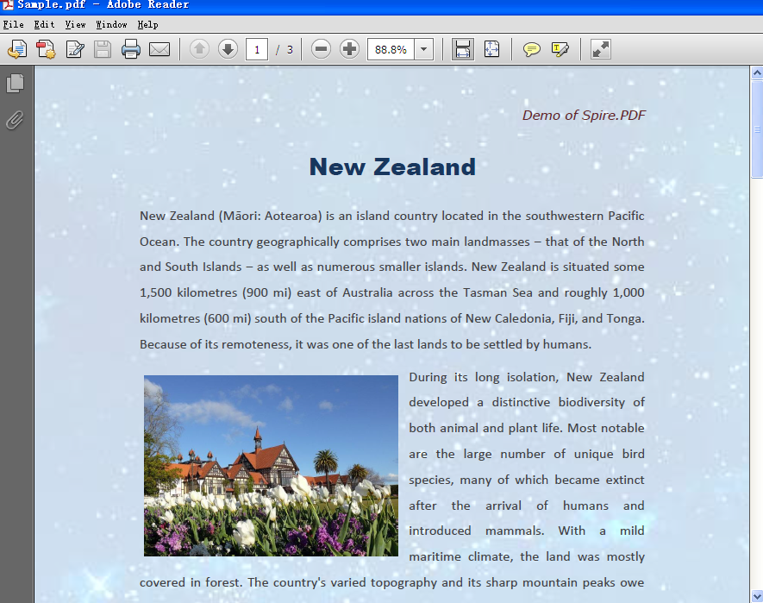

Here comes to the code snippet of how to rotate an existing PDF file in C#.

**Step 1**: Create a new instance of PdfDocument and load a PDF document from file.

PdfDocument doc = new PdfDocument();

doc.LoadFromFile("Sample.pdf");

**Step 2**: Get the first page of the loaded PDF file.

PdfPageBase page = doc.Pages[0];

**Step 3**: Set the rotation of page to RotateAngle90.

page.Rotation = PdfPageRotateAngle.RotateAngle90;

**Step 4**: Save the document to file.

doc.SaveToFile("Result.pdf");

The effective screenshot which rotate 90 degree clockwise:

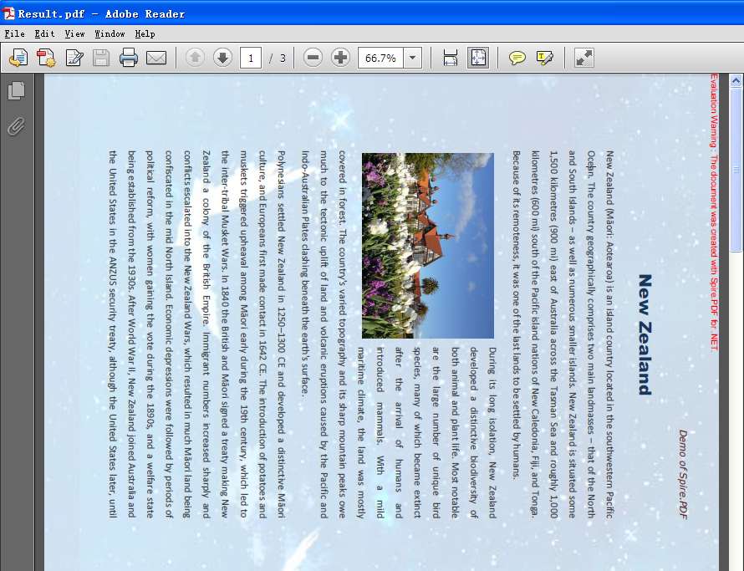

Full codes:

static void Main(string[] args)

{

PdfDocument doc = new PdfDocument();

doc.LoadFromFile("Sample.pdf");

PdfPageBase page = doc.Pages[0];

page.Rotation = PdfPageRotateAngle.RotateAngle90;

doc.SaveToFile("Result.pdf");

}